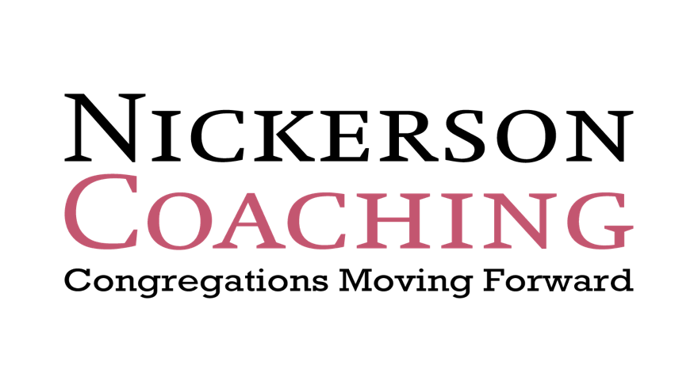
Rev. Paul Nickerson
Nickersonp@comcast.net
Nickersoncoaching.com
8 Iverson Road, Beverly, MA. 01915
508-930-9327
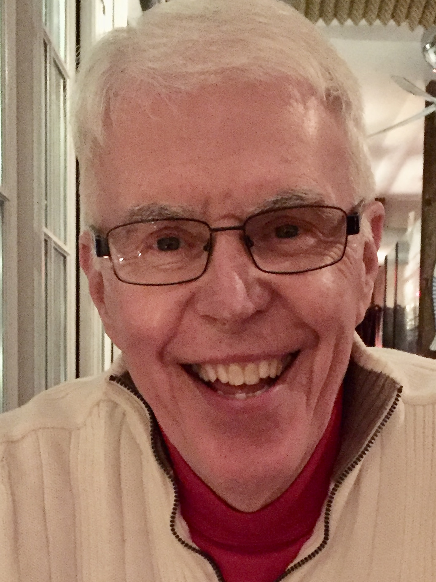
What Makes for a Vital Church Today. Oct 21, 2023
10:00 AM to 3:00 PM. Sponsored by the Northern Illinois UMC Conference

There are several purposes for today’s workshop:
- To overview key areas of church life that lead to vitality.
- To preview the “Reaching New People” process for churches that will be starting a new cohort in January. You will be hearing from churches that have been through this training and coaching process.
- For the new churches, we will look toward a start date of the process.
- For churches who have been in Cohorts, the goal today is to discern what area of church life you would like to work on, while continuing to reach new people.

Introductions and Opening devotional

Section One: Current Realities for Churches

There was a time when the church and culture ______________.
Most people had parents and grandparents who passed on a
_______________________.
Starting in the 1990’s, this passing of the faith stopped.

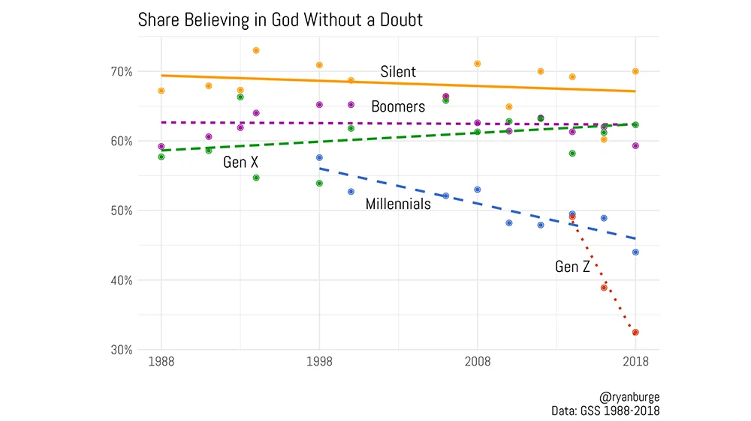_________________________.

The Effects:
- “__________” make up 30% of the population.
- This segment has little or ____ religious experience.
- These are the “____________________”

Add to this:
- In the past 25 years, _________ million church members left their churches. These are the “de-churched”. Several factors played into this exodus:
  - The view that it was synonymous to be “Christian” and be “American” faded, particularly after the end of the Cold War.
  - Americans began to associate “religion” with the Far Right excesses and church scandals/fights.
  - With the dawn of the internet, people saw alternatives
________________.
As a result of these trends…..
- Less than _____% of people attend anywhere.
- Mainline Protestants make up ________% of the U.S. Population.
- _____% of churches have ______ or fewer in weekly worship.
- Only _____% average 250 or more.

But there are reasons for hope!
_____% of the US population is “_________” and want a place of community.
Over ________% of all the age generations say they are “___________”.
Both un-churched and de-churched say they welcome _____________ in trusting relationships with church people.
Most people who left churches still have __________
Christian beliefs.

Action Step: Discuss as a Team which of these realities you have seen in your church. Have one Team member take notes.

Section Two: Vital Churches have a clear sense of their Purpose, their Vision, and a Plan to get there.

The three basic questions are:
- Why do we exist as a church? (Purpose)
- Where are we going? (Vision)
- How will we get there? (Action Plan)

- Healthy churches can state, in a sentence, why they exist as a church. This sentence needs to be owned by the congregation and shared with the community around the church. A Purpose Statement becomes the __________________for what a church does and does not do.

Some sample Purpose Statements
_______ Church seeks to assist as many people as possible in becoming fully developing followers of Christ.
Our purpose is help people belong, grow and engage.
Our purpose is to lead ordinary people to extraordinary life in Christ.
People matter to God and so they matter to us at ___________ Church.
We are the waterfall of God’s Grace to ____________ (name of town).
The Purpose of ___________ Church is to be a faith community fostering belonging, believing, and becoming all that God intends.

Meeting in Grace, Transformed by Love, Serving with Joy.

- Healthy churches then pray, discern, dream and “paint a picture” of what their church will look like and will be doing in the next 2-3 years. This is their “vision”.

This “Statement” should be a one-page narrative of what God is calling the Church to do. It needs to be specific with SMART Goals:

Specific

Measurable

Achievable

Relevant

Time-bound

Here is one example from Carrollton UMC in Ohio.
Draft Vision Statement
The Mission—The mission of the Church is to make disciples of Jesus Christ for the transformation of the world.
The Purpose- To follow Jesus and share His love by praying, serving, and encouraging all people so they may be in a closer relationship with God.
Carrollton First UMC/The Bridge will strive to make difference in our community by the year 2021 by:
- Prayer: To see an ever increasing number of people praying for: 1) Mission (local and world- wide); 2) How CFUMC/The Bridge can be the light in the community that brings everyone together.
- Leadership and Mobilization: To provide ongoing leadership to the entire church in the area of outreach and serve as a mobilizing force within the congregation in order to provide outreach to the Carroll County Area
- Partnerships: To intentionally work to provide opportunities of partnership in missions between current programs in our community and to create new programs that meet the communities needs and invite others to partner with us in those ventures. To work to create partnerships with churches around the community.
- Visibility: The community will know where we are located and the services we offer.
In 2021 Carrollton First UM/The Bridge will be a beacon of light in our community through partnerships and starting new programs that will:
Reach community youth with an extensive list of services including youth group, small groups, sports, activities related to major mile markers (prom, homecoming, graduation, etc.)
Have modified the Carrollton First UMC building to become more handicap accessible.
Increase worship total Sunday Worship by 20%
Hire Staff that will move us on a Discipleship Pathway and bring us more social media presence.
Offer Programs and Outreach in our community through ACTS (Acts of Kindness), providing assistance to our Shut-In population, encouraging more participation at school functions, offering a blessing box or a need based pantry. We will also offer more opportunities to minister to families through parent night out and or free babysitting.

- Action Plan

Many churches come up with “great ideas” but no plan to follow through. This is where an Action Plan is developed, overseen by leadership, and reviewed at Charge Conferences.

Again, a brief sample from Carrollton of the first 90 days of their Action Plan.
0-90 Days
- Hire a Director of Communications
  - Purpose: To bring consistency between all three services with one website, church app, morning announcements, digital newsletter, videos, livestreaming, social media, online giving, etc. Create an atmosphere of invitation!
  - Responsible Person/Team: SPPRC
  - Needed Resources: Job Description to be drafted by pastoral staff and approved by SPPRC
  - Deadline: Start Advertising by middle of May 2019 – have someone hired by August 2019
  - Measurable Outcomes:
    - By November 2019 there will be a proposed budget for expenses associated with new website, church app, social media presence, live-streaming, videos, etc.
    - By December 2019 we will be utilizing in worship videos/testimonies/announcements created in house to bring awareness to needs, joys and concerns of our congregation.
    - By Easter of 2020 we will have one cohesive website, Facebook and Twitter presence.

- New Attendee and Current Attendee Follow Up System
  - Purpose: To be in contact with first time guests and to follow up with regular attendees that may be absent for several weeks.
  - Responsible Person/Team: Evangelism & Associate Pastor
  - Needed Resources: Access to Communicator Card Info
  - Deadline: Start- July

- Ministry Audit
  - Purpose: To create a time for Pastoral Staff to learn about existing ministries and those who lead them. Offer support, encouragement and tools needed for success.
  - Responsible Person/Team: Pastoral Staff and Team Leaders
  - Needed Resources: Calendar and Time
  - Deadline: July –October 2019

- Hire Nursery Coordinator/Worker
  - Purpose: To have consistent workers at all three services and to recruit additional help
  - Responsible Person/Team: SPPRC
  - Needed Resources: Job Description to be drafted by Pastoral Staff and SPPRC
  - Deadline: Deadline: Start advertising by middle of May 2019 – have someone hired by September 2019.

Action Step: Does your church need to develop a Purpose Statement, Vision, and Action Plan?

Section Three: Vital Churches Understand their Mission Field
Churches do not exist in a “vacuum”. Vital churches become experts on their mission field.

Key practices:
Look at demographics:

Interview Key Community leaders:

Do Prayer Walks:

Write a description of the “next group” the church will reach out to and a key need or two the church will address.

Action Step: How clear is your church’s understanding of the mission field?

Session Four: Vital Churches reach new people and make disciples.

Hear the stories of Cohort Churches who have worked on reaching new people over the past couple of years.

Action Step:
- For new churches what might be your first step to reach out to new people?

- For Cohort churches, what is your next step?

Session Five: Vital Churches develop generous givers.

- In 1980, churches received ___% of all charitable gifts. Today,
_____%.
- The number of non-profits has greatly increased, and they know how to ________ , ____________, and __________.

Engagement and _____________ are the key.
-People need to see the ______________ of their gifts.
-Saying __________ is critical

Vital Churches focus on two strategies:

- Developing a Year-round process of discipleship and stewardship.

- Developing an effective stewardship drive

The goal is to develop ______________ people who reflect generosity in their lifestyle.

Action Step: Is your church well-funded? Are you developing generous givers?

Session Six: Vital Churches develop a clear discipleship pathway.

Often churches’ approach to discipleship is “_________________________”.

People, new and long-term members need to know how to take their ____________ step in going deeper in faith.

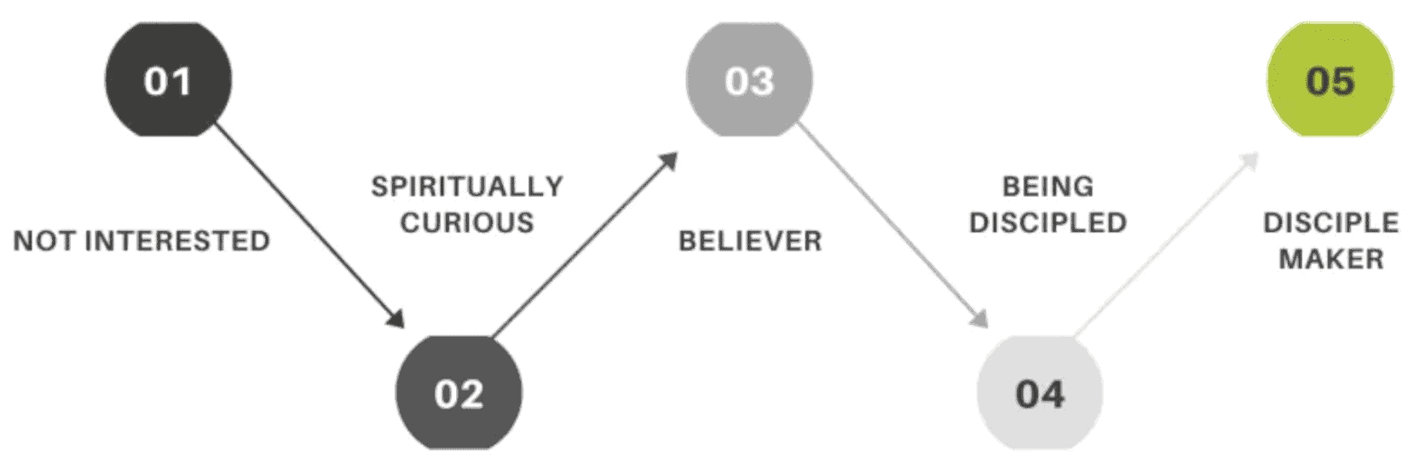

Vital churches look at the following strategies:

- A growth/ministry plan for every member

- Creating “environments” for growth

- A wide use of in-person and online gatherings

- “Playlists” that can be used for both self-study and small groups.

- A person or team to oversee the process.

Action Step: Does your church have a systematic approach to discipleship? What steps do you need to take?

For churches new to the process

Name of Church:

Team members names and emails:

What questions do you have about the “Reaching New People Process?

Date for Initial Training:
For Churches Who have been part of a Cohort.

Name of Church:

While continuing to reach new people, are there other areas of church life you would like to receive additional training and coaching?

____Vision Discernment and Action Plan

____ Clearer Understanding of the Mission field

____ Continued work on reaching new people

____ Stewardship Development

____ Discipleship Development process

____ Other

Other notes

