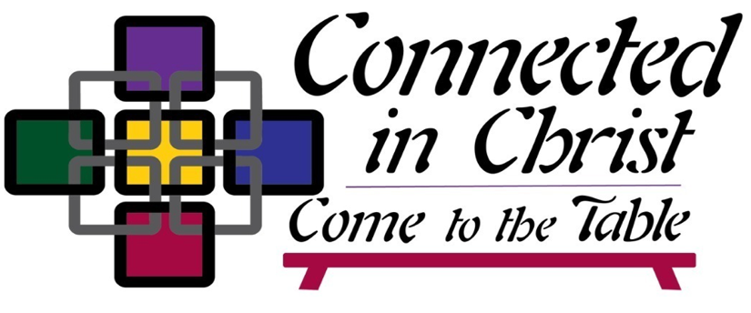

[Name] United Methodist Church
2023 Church Conference

Agenda

WELCOME Pastor

CALL TO ORDER DS/Presiding Elder

OPENING PRAYER Lay Leader

HYMN “Many Gifts, One Spirit” (UMH #114) or a hymn choice by the church

SCRIPTURE Lay Leader
(Choose one of the following passages or read both.)

1 Corinthians 12:12-13

¹² For just as the body is one and has many members, and all the members of the body, though many, are one body, so it is with Christ. ¹³ For in the one Spirit we were all baptized into one body—Jews or Greeks, slaves or free—and we were all made to drink of one Spirit. (NRSV)

Matthew 9: 10-12

¹⁰ And as he sat at dinner^{[a]} in the house, many tax-collectors and sinners came and were sitting^{[b]} with him and his disciples. ¹¹ When the Pharisees saw this, they said to his disciples, ‘Why does your teacher eat with tax-collectors and sinners?’ ¹² But when he heard this, he said, ‘Those who are well have no need of a physician, but those who are sick. ¹³ Go and learn what this means, “I desire mercy, not sacrifice.” For I have come to call not the righteous but sinners.’ (NRSV)
MESSAGE DS/Presiding Elder

“I believe the tables of the gospels suggest God’s dream for us and they call us to become whole people who live in a healing and whole community. Our best parables are about inviting those in the highways and hedges to the table, about taking the last seat and putting others before us. . .Perhaps the most remembered scripture about the table is: ‘Thou preparest a table before me in the presence of mine enemies.’ The psalm suggests God is preparing the table and calls us to: ‘come to the table and be God’s table people even in the presence of hurt and division.”
(Bishop Dan Schwerin during his State of the Church address at the 2023 NIC Annual Conference)

HOLY CONFERENCING
- How have you experienced God’s love and grace at a table?
- How do you extend Christ’s table in your life and through your mission and ministry?
- How do we become one body in Christ?

Litany (Unison)
We are called to be God’s table.
We gather as a beloved community
Blessed with a theology of abundance
To equip vital faith communities
That we would make disciples of Jesus Christ
For the transformation of the world.
First and foremost, we believe God is preparing this table and that collectively, we are at a moment in time that our prayer could be framed as, ‘by Your Spirit make us one in Christ that we may be one in ministry.’ This is, first, God’s table, a table of life in Christ as one body.
(Adapted from Bishop Dan Schwerin’s State of the Church address)

HYMN “One Bread, One Body” (UMH #620) or a hymn/song selected by the church

BUSINESS:
- Leadership Nominations and Election
- Clergy Compensation
- Ministry Recommendations
- Lay Servant Reports
- Additional Business

SACRAMENT OF THE HOLY COMMUNION Hymnal pages 15-16
DS/Presiding Elder
(The host pastor prepares the elements. Communion is served in accordance with the church’s practice.)

DISMISSAL AND BLESSING Pastor

